Spirit Life Bible College and Seminary

Application

106 South Street West Hartford CT, 06110
(860) 461-7355
spiritlifebc@bccwh.org

Applicant Information
Name:
Date of birth: | Cell Phone: |  | Home Phone:
Current address:
City: | State: |  | ZIP Code:
E-mail: | Degree or Personal Growth (circle one) |  | In person or online:
Class Time (circle one each day): Tues 10 am or 6pm Thur 10 am or 6 pm |  | Current Degree Status:

Employment Information
Current employer:
Employer address: |  |  | How long?
Phone: | E-mail: |  | Fax:
City: | State: |  | ZIP Code:

Emergency Contact
Name of a relative not residing with you:
Address: |  |  | Phone:
City: | State: |  | ZIP Code:
Relationship:

References
Name | Address |  | Phone
Signature of applicant: |  |  | Date:
Signature of Parent [for under 18 students] |  |  | Date:
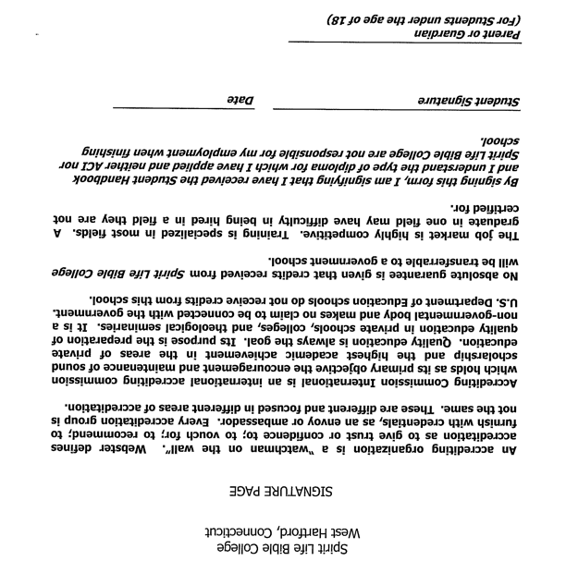

Spirit Life Bible College nd Seminary, West Hartford, CT is a religious institution No claim is made that any secular school will accept course work done at this school. This school is not affiliated with the Department of Higher Education in Connecticut.

I understand that the Spirit Life Bible College is a parochial institiution. Credits are not guaranteed to be accepted by secular or state-run programs.

Accrediting Commission International is primarily a private school association unrelated to government accreditation.

____________________________________________ ____________________________
Student Signature Date

